**Lab 2: Package Design and Modelling**

Open The AEDT application. Go to Project -> Q3D extractor Design

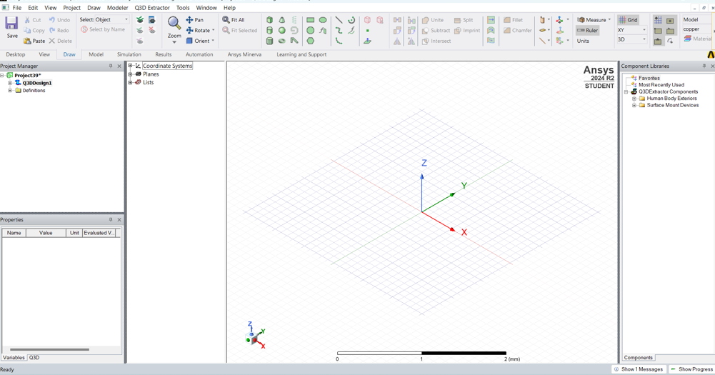

Click Rectangle and draw it with the required values.

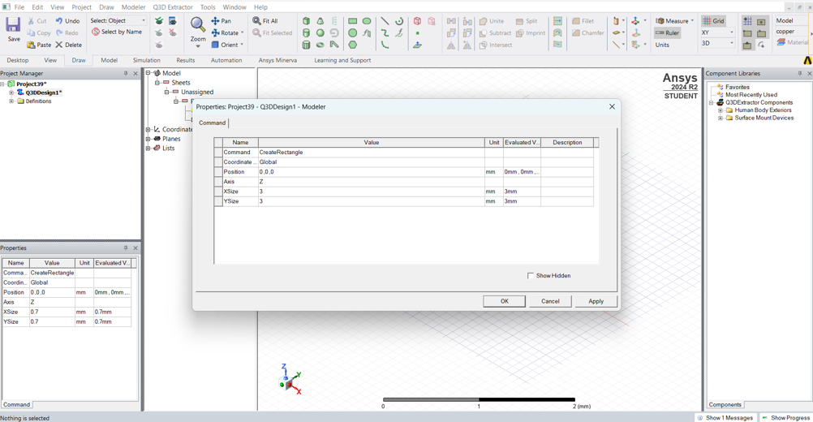

Click on the rectangle -> Modeler -> Surface -> Thicken Sheet. Set the thickness to 0.2mm

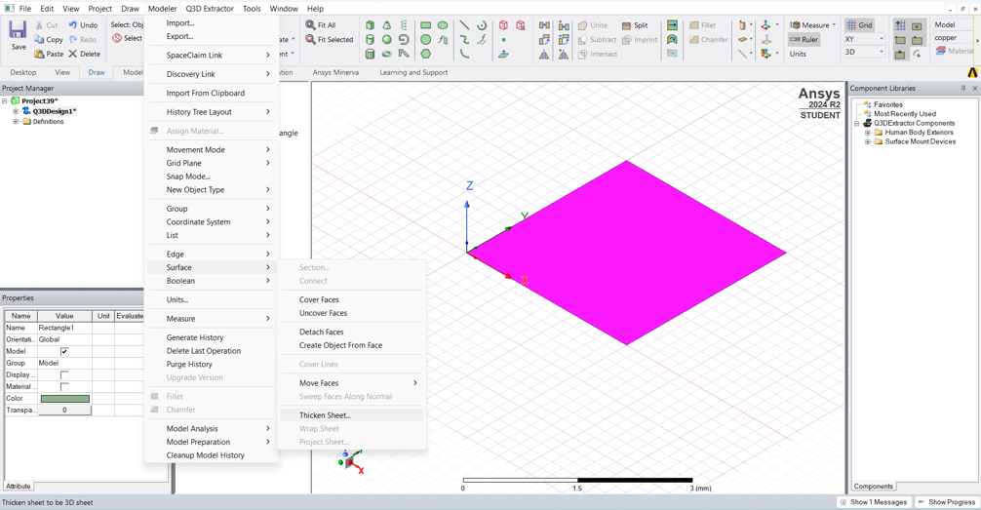

name the rectangle as Die.

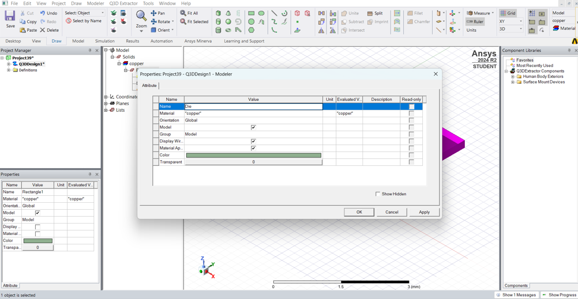

Select the material as silicon.

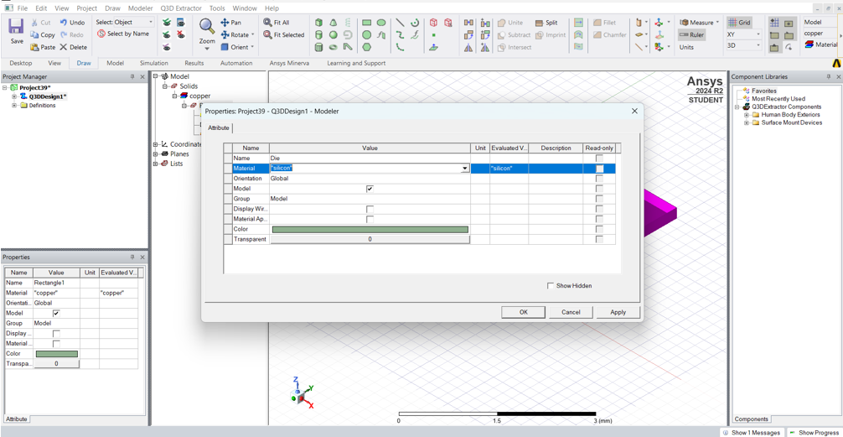

Draw another rectangle which is bigger than the previous one.

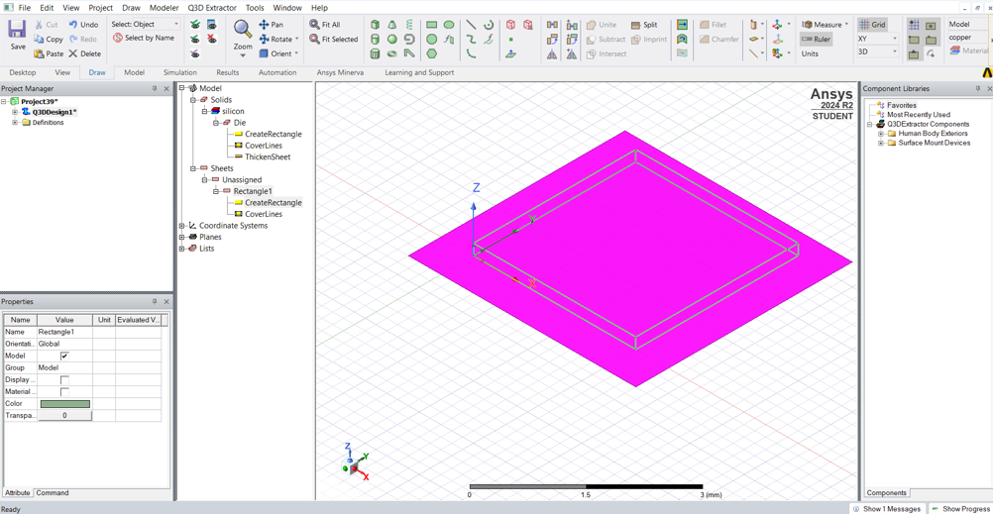

Select the required dimensions.

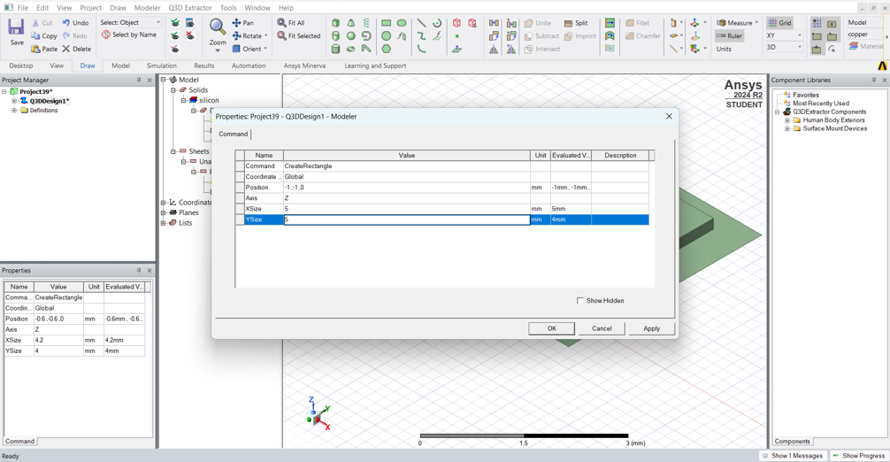

Set the thickness to -0.5mm

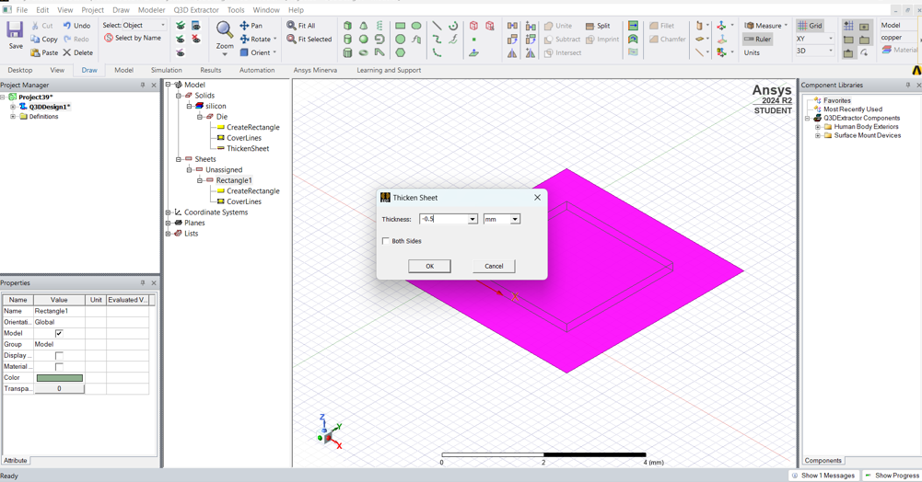

Change the name as Substrate and assign FR4_epoxy material. Also change the position of substrate accordingly.

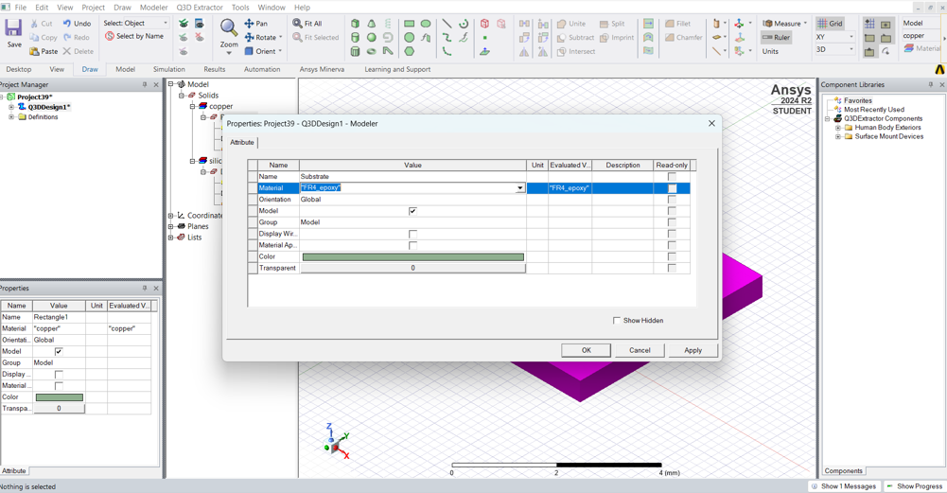

Draw another rectangle over the die with the same dimensions.

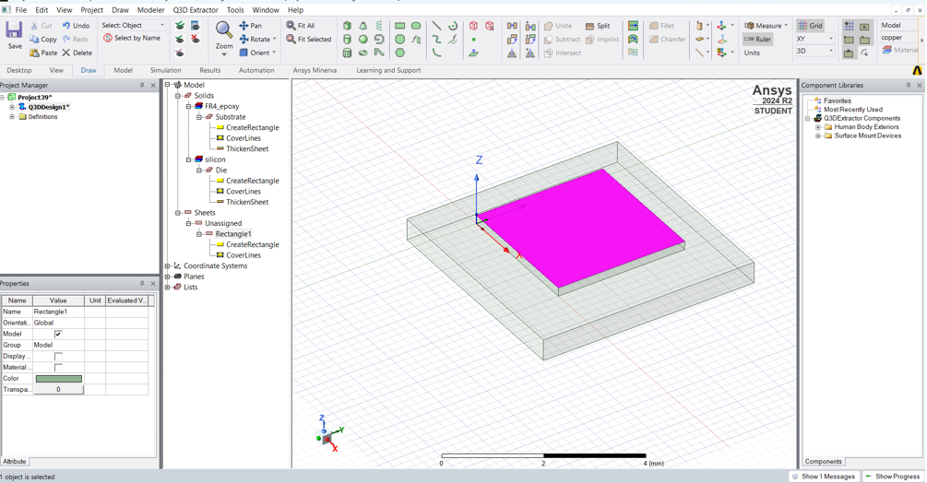

Set the required dimensions and position and set thickness to -0.1mm

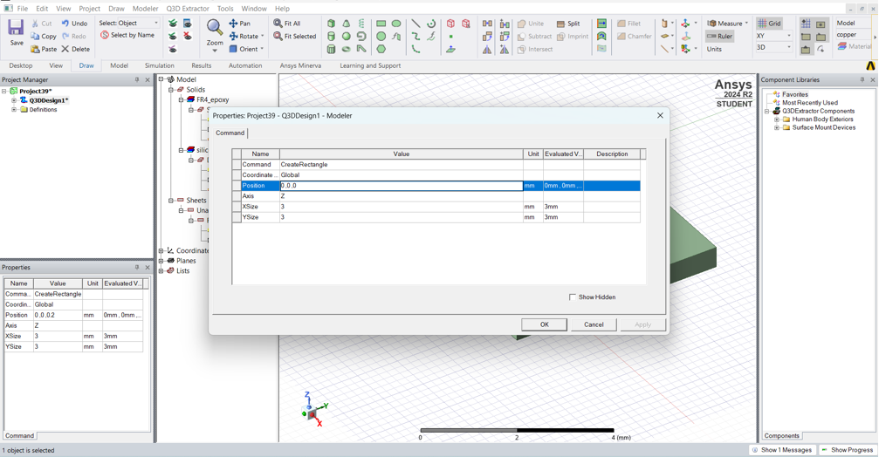

Change the name to DieAttach and assign modified_epoxy material.

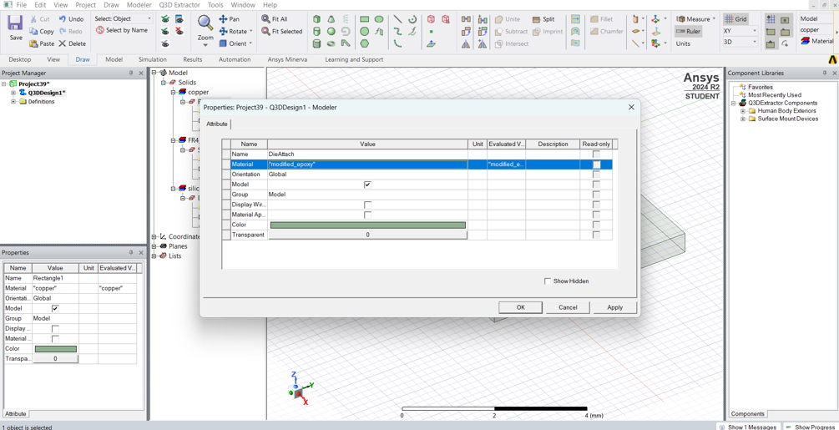

Draw a small rectangle on the Die and set the required position and dimensions. Set thickness as 0.005mm

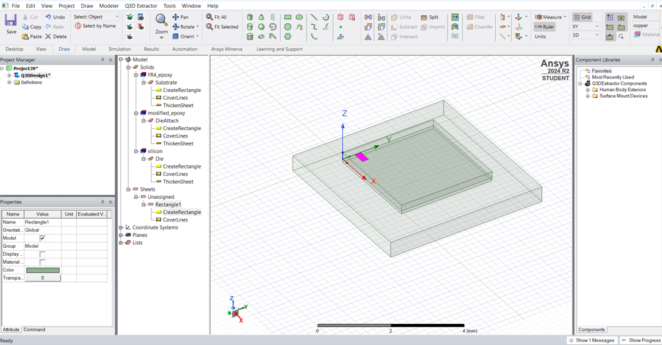

Similarly, draw a small rectangle on the substrate.

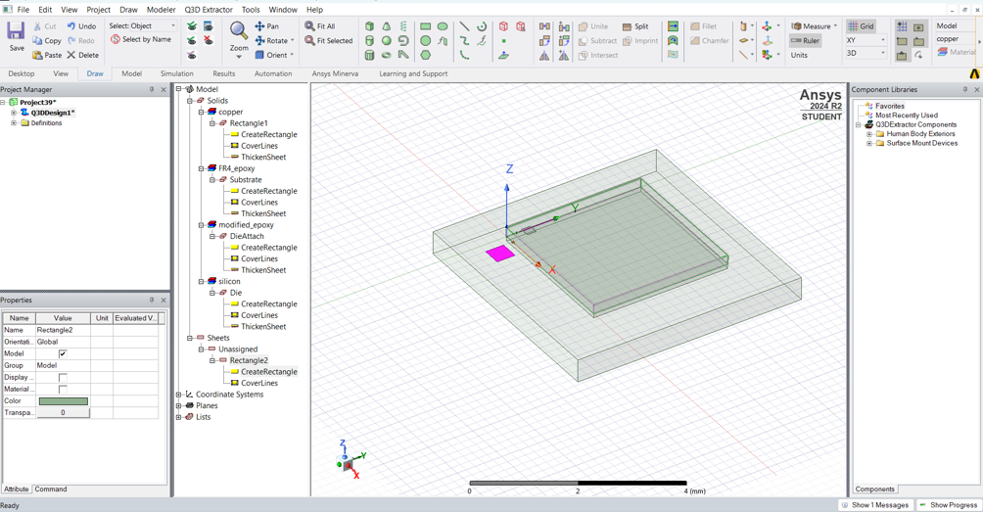

Set the required position and dimensions.

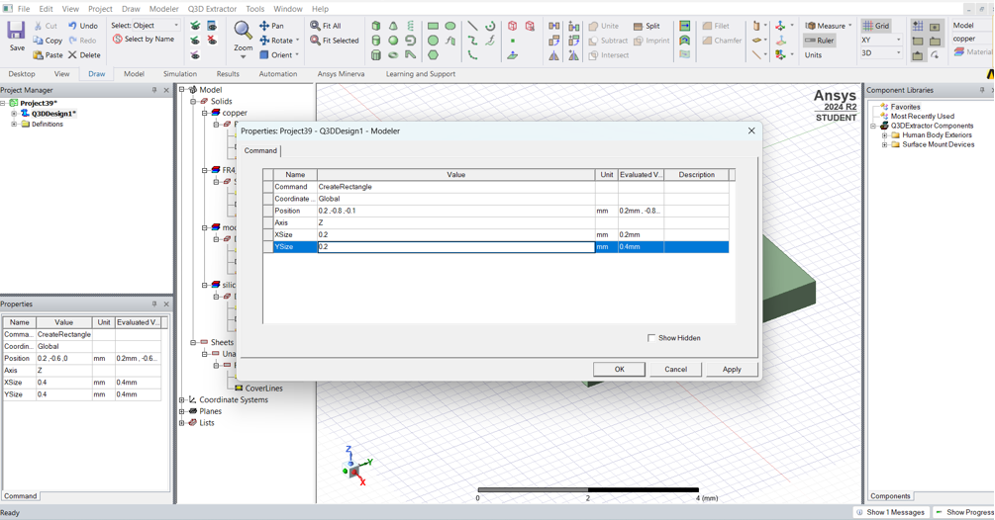

Change the name of rectangle on die as Diebondpad and similarly change the name of rectangle on substrate as Substratebondpad.

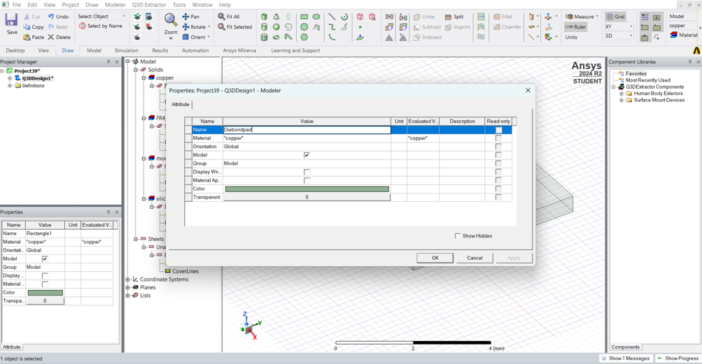

Click on Bondwire and draw from center of Diebondpad to center of Substratebondpad.

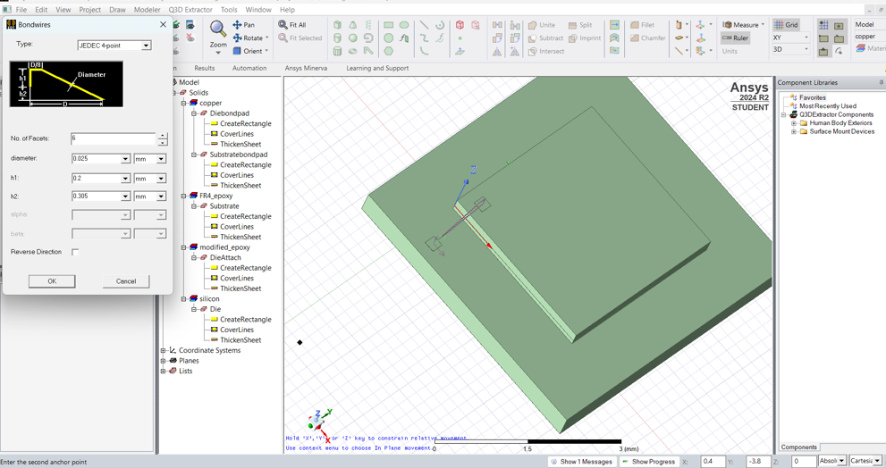

Assign material of bondwire as gold and change the color.

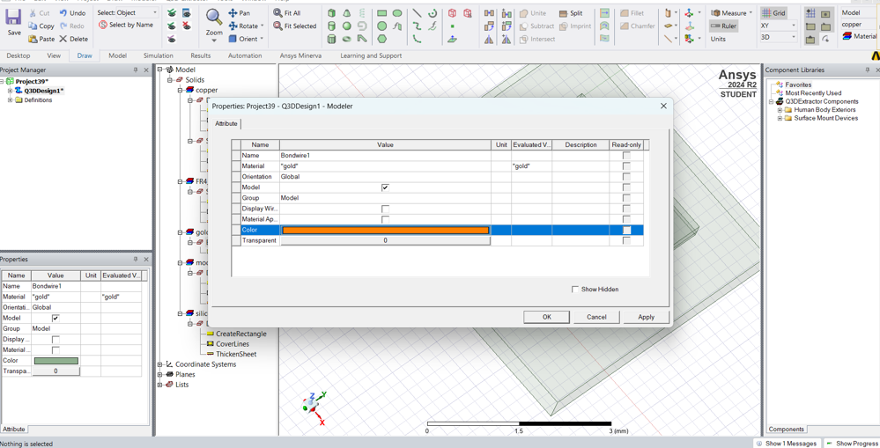

Click on Diebondpad -> Edit -> Duplicate -> Along Line

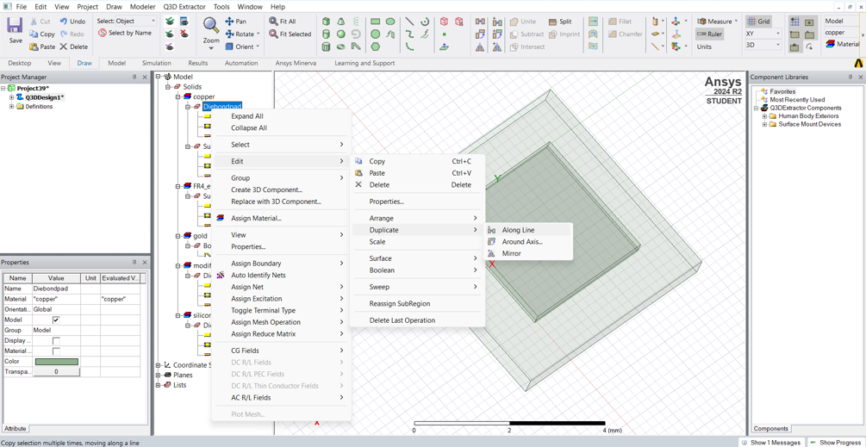

Set the number to 7.

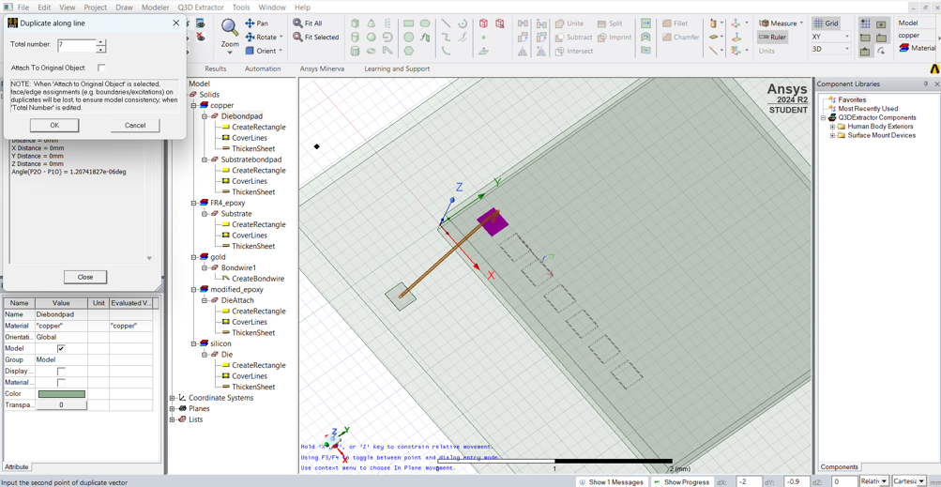

Duplicate the Substratebondpad and bondwires.

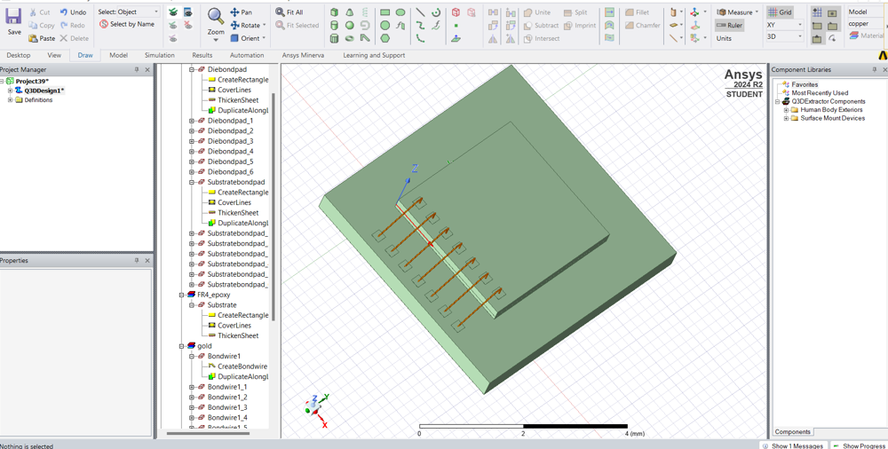

Repeat on the remaining 3 sides.

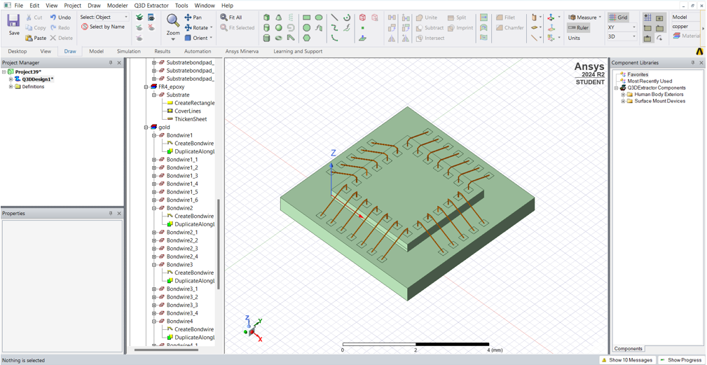

Draw a rectangle on the substrate with the same dimensions and set the thickness to 1.2mm

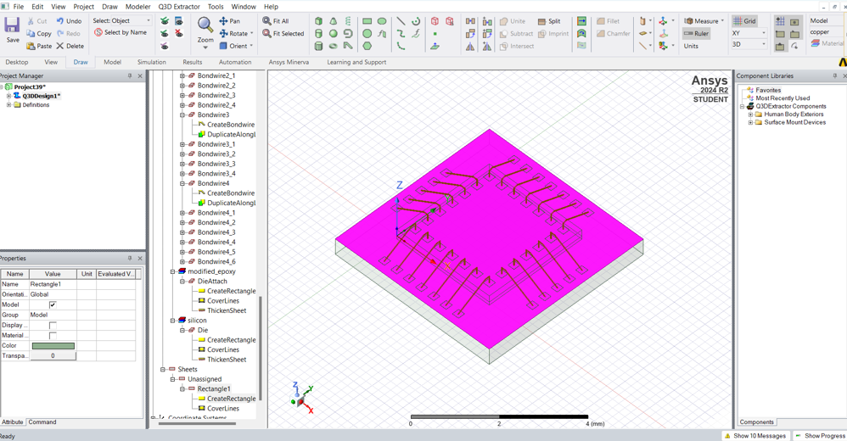

Change the name as MoldCompound and assign epoxy_Kevlar_xy material.

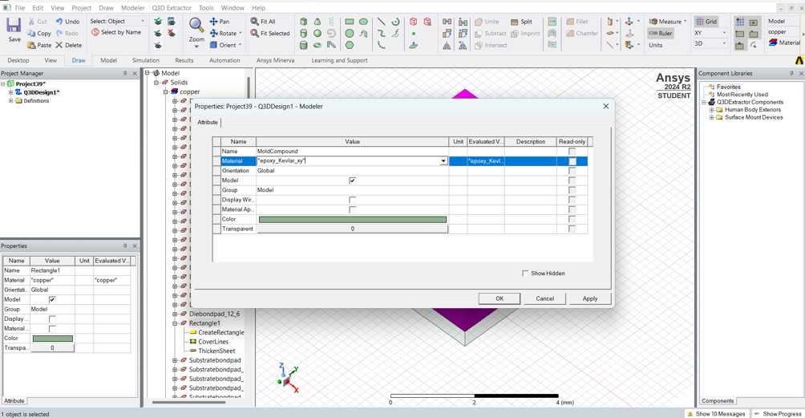

The final package is obtained

